Lecture 15 | Coreference Resolution

* What is coreference?
  + Identify all noun phrases (mentions) that refer to the same real-world entity
  + Example:

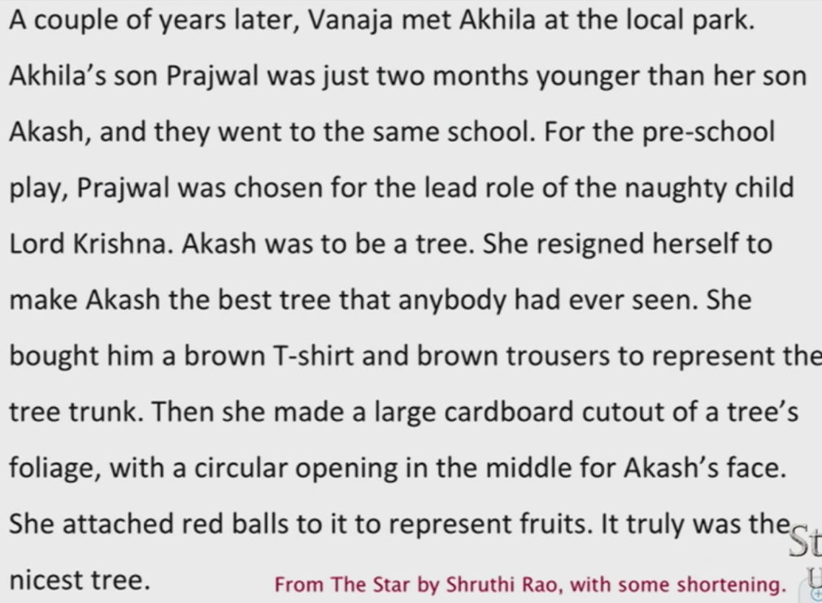

* + - Vanaja and Akhila are the main entities
* Noun phrases refer to entities in the world, many pairs of noun phrases co-refer, some nested inside others

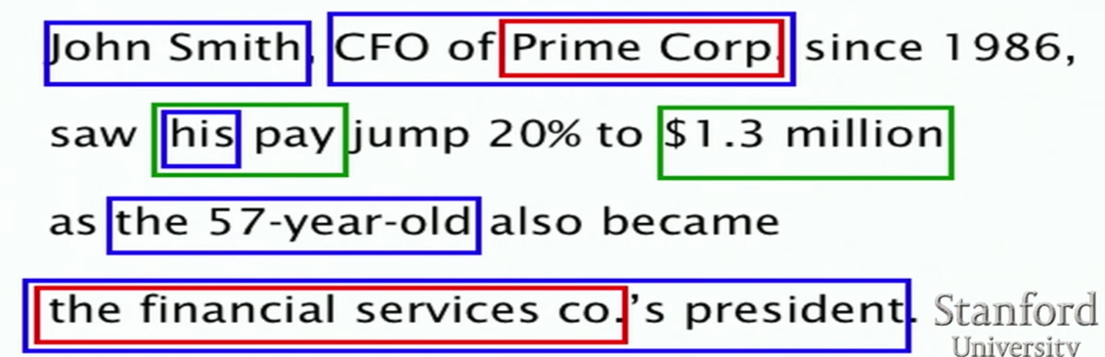

* Coreference Resolution has application in machine translation, text summarisation and tasks like information extraction and question answering
* B^3 is the evaluation metric for coreference evaluation
  + Precision and recall for entities in a reference chain
  + Precision: % of elements in a hypothesised reference chain that are in the true reference chain
  + Recall: % of elements in a true reference chain that are in the hypothesised reference chain
  + Overall precision and recall are the average of per-chain precision and recall
* Kinds of reference
  + Referring expressions (more common in newswire, generally harder in practice)
    - John Smith
    - President Smith
    - The president
  + Free variables
    - Smith saw his pay increase
  + Bound variables
    - The dancer hurt herself
  + In linguistic theory most of the work is dealt with the free and bound variables and trying to interpret what they are going to be coreferent with – “anaphora resolution”
* Not all noun phrases (NPs) are referring
  + For example: “Every dancer twisted her knee” and “No dancer twisted her knee”
  + There are three NPs in each of the sentences above, first one is non-referential and the other two aren’t either
* **Coreference** is when two mentions refer to the same entity in the world
* **The relation of anaphora** is when a term (anaphor) refers to another term (antecedent) and the interpretation of the anaphor is in some way determined by the interpretation of the antecedent
  + Not all anaphoric relations are coreferential. For example, “We went to see **a concert** last night. **The tickets** were really expensive”
  + This is referred to as **bridging anaphora**
* **Cataphora**

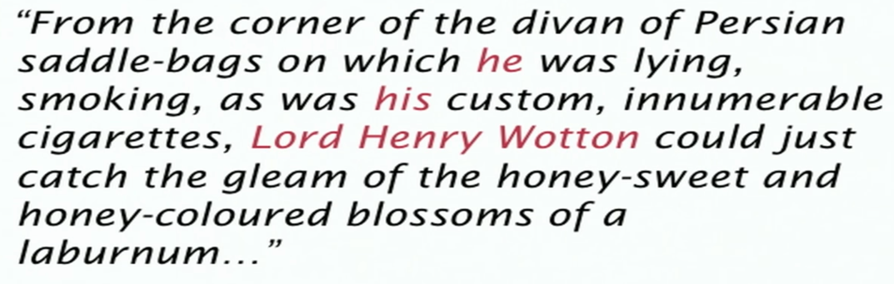

* Traditional pronominal anaphora resolution: Hobbs’ naïve algo

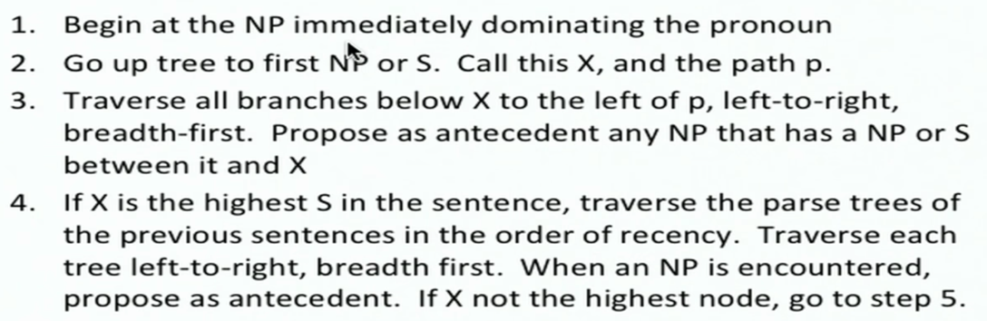

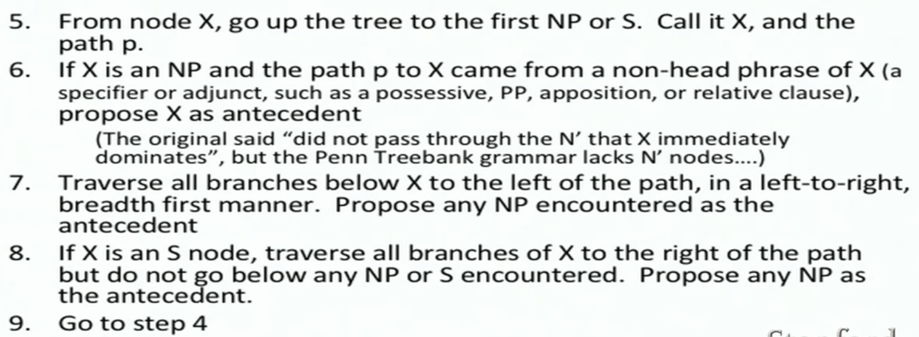

* Kinds of coreference models
  + Mention pair models
    - Treat coreference chains as a collection of pairwise links
    - Make independent pairwise decisions
    - Reconcile them in some deterministic way
  + Mention ranking models
    - Explicitly rank all candidate antecedents for a mention
  + Entity-mention models
    - A cleaner, but less studied approach
    - Posit single underlying entities
    - Each mention is linked to a discourse entity
    - Explicitly cluster mentions of the same discourse entity
* Supervised mention-pair model
  + Given a current mention and earlier mentions, classify whether the current mention corefers with each earlier mention or not given the surrounding context (yes/no?)



* + Use any classifier, obtain positive examples from training data, generate negative examples by pairing each mention with other incorrect mentions, binary classification task
  + Features for coreference resolution

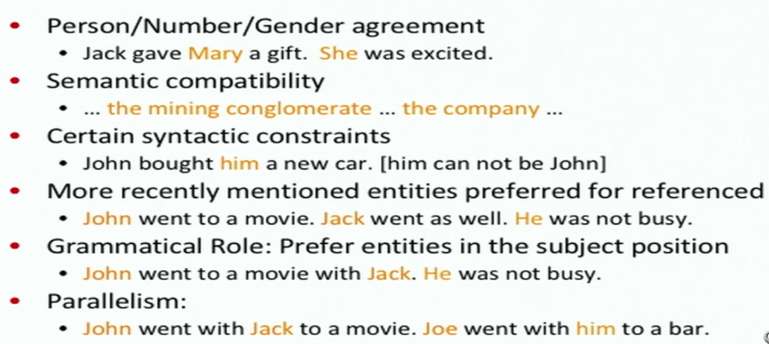

* Deep learning and coreference models
  + In 2017, there are 4 papers that attempt to use neural networks, deep learning to do coreference
  + Wiseman, Rush, Shieber, and Weston (ACL 2015)
    - Mention-pair model. Only partially neural network system over conventional, categorical coreference features
  + Wiseman, Rush, and Shieber (NAACL 2016)
    - Uses RNNs to learn global representations of entity clusters from mentions
  + Clark and Manning (ACL 2016)
    - An entity-mention model based around clustering using distributed representations of mentions and entity clusters
  + Clark and Manning (EMNLP 2016)
    - Explores deep reinforcement learning to improve a mention-pair model
* Deep reinforcement learning for mention-ranking coreference models
  + Coreference resolution is a document-level structured prediction task
  + E.g. **“I voted for Nader because he was most aligned with my values.” she said**

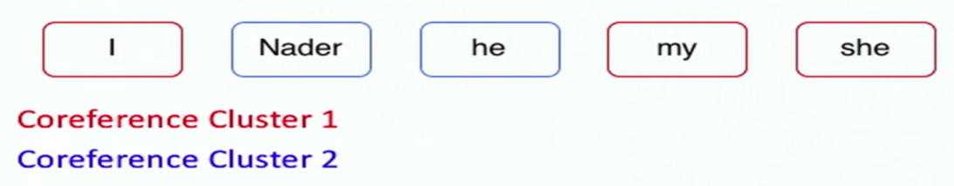

* + Mention-ranking models – dominant approach to coreference resolution in recent years
    - Assign each mention its highest scoring candidate antecedent according to the model

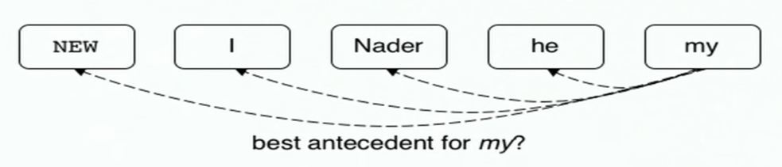

S(NEW, my) = 0.5

**S(I, my) = 1**

S(Nader, my) = -0.2

S(he, my) = -0.4

* + - Infer global structure by making a sequence of local decisions
  + Neural mention-pair model
    - Standard feed-forward neural network
    - Input layer: word embeddings and a few categorical features to capture phrase similarities

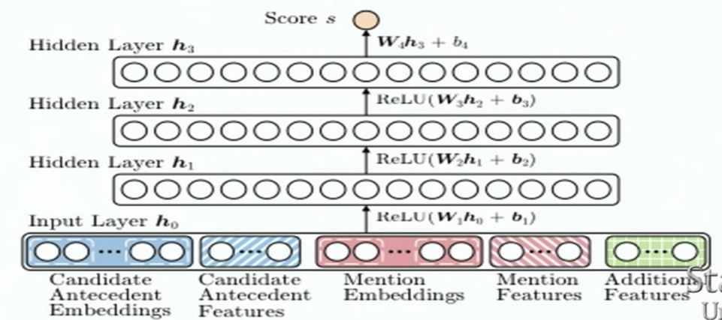

* + - Uses pretrained word embeddings
    - No RNNS, just take certain words and use feed-forward network
    - Use deep network
    - Dropout
  + Use reinforcement learning to learn which local decisions lead to a good clustering (no pesky hyperparameter search). Prior work on this has been to heuristically defined the importance of a coreference decision, which requires careful tuning with hyperparameters
  + Prior work error types:
    - False new
    - False anaphoric
    - Wrong link
  + Prior work heuristic loss function

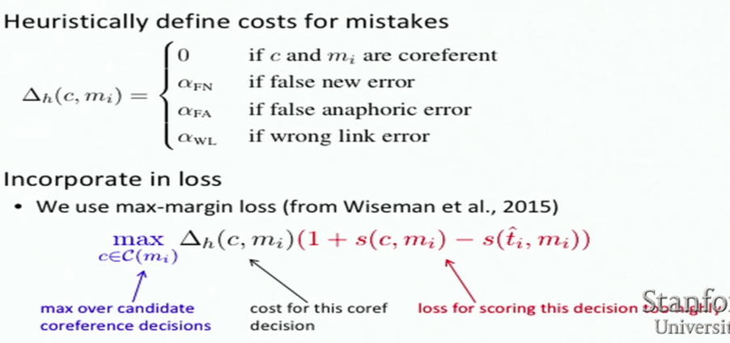

* + - Disadvantages:
      * Grid search over hyperparameters requires training many instances of the same model
      * At best, loss is correlated with eval metrics
  + Reinforcement method:

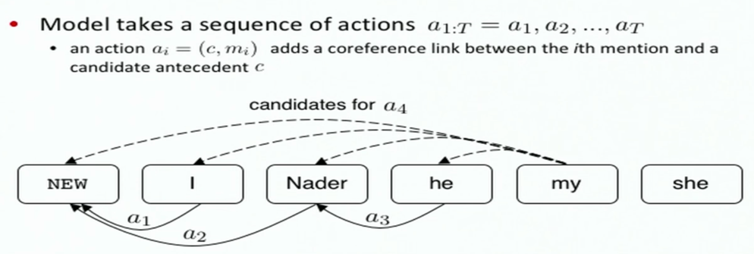

* + - After completing a sequence of actions, the model receives a reward (B^3)

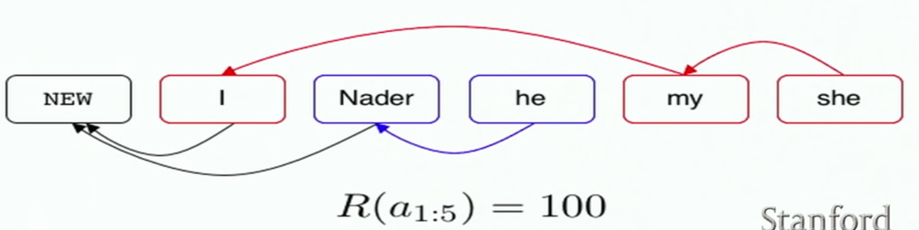

* + - Clark and Manning (2016) explore using two RL methods:
      * REINFORCE algo (Williams, 1992)

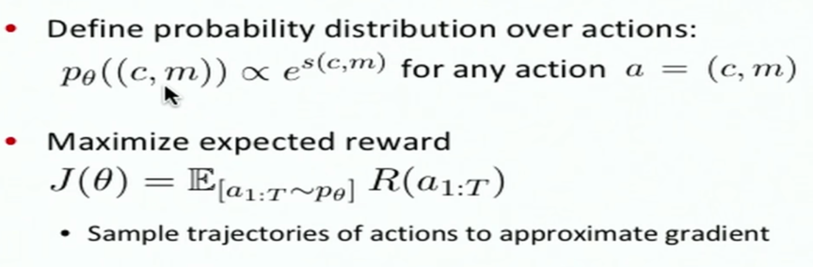

Competitive with heuristic loss but has a small disadvantage which is that REINFORCE maximises performance in expectation

* + - * Reward-rescaling (novel)
        + Incorporate rewards into max-margin objective’s slack rescaling
        + Since actions are independent, we can change an action to a different one and see what reward we would have gotten instead

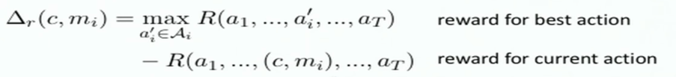

* + - * + Cost is the regret of taking the action